Automated Network Request Management in ServiceNow
ServiceNow Custom Application
Project | Automated Network Request Management
Platform | ServiceNow
Interface | Service Portal
WorkFlow | Catalog → Records → Approval → Task → Status → Notification

TABLE OF CONTENTS
S. No. | Chapter / Section | Page No.
1 | Project Overview | 3
2 | Problem Statement and Objectives | 3
3 | Application and Data Architecture | 4
4 | Requirement Analysis and Planning | 5
5 | Catalog Item and Variable Configuration | 6
6 | Service Portal Interface and Usability | 7
7 | Flow Designer Automation | 8
8 | Approvals and Network Task | 9
9 | Business Rules, UI Logic and ACLs | 10
10 | Notifications and Status Tracking | 11
11 | End-to-End Functional Flow | 12
12 | Testing and Validation | 13
13 | Deployment, Documentation and Presentation | 14
14 | Conclusion and Future Enhancements | 14

- Project Overview
The Automated Network Request Management in ServiceNow project provides a structured way to submit and manage network-related service requests. It automates the process from request submission to approval, Network Task creation, status updates, and notifications.
The project uses Service Catalog, Flow Designer, custom tables, Approvals, Business Rules, ACLs, and Notifications to manage the complete request lifecycle.
The solution provides the following capabilities:
- Users can submit network requests through the Service Portal.
- Required request information is captured using structured catalog variables.
- The Requested For field is automatically populated with the current user.
- ServiceNow creates Request and Requested Item records.
- Flow Designer creates the Network Database record and routes the request for approval.
- An approved request generates a Network Task for the fulfilment team.
- Status changes and email notifications keep concerned users informed.
- Problem Statement and Objectives
Network service requests can become difficult to manage when they are submitted through unstructured channels. This project provides a controlled ServiceNow process for collecting request details, obtaining approval, creating fulfilment tasks, and communicating progress.
Objectives
- Create a centralized Network Request Catalog Item.
- Capture request details using structured catalog variables.
- Automate approval and Network Task creation.
- Track request status throughout the lifecycle.
- Send notifications to concerned users.
Improve request management through Flow Designer, ACLs, and Update Sets.
- Application and Data Architecture
The project is developed on the ServiceNow platform using the Service Catalog, custom tables, Flow Designer, and Service Portal.
The application follows this workflow:
Catalog Item → Request → Requested Item → Network Database → Approval → Network Task → Status Update → Notification
The main components are:
- Service Catalog: Allows users to submit network requests.
- Catalog Variables: Collect required request details.
- Custom Tables: Store Network Database and Network Task records.
- Flow Designer: Automates approvals and task creation.
- Service Portal: Provides the user interface for submitting and tracking requests.
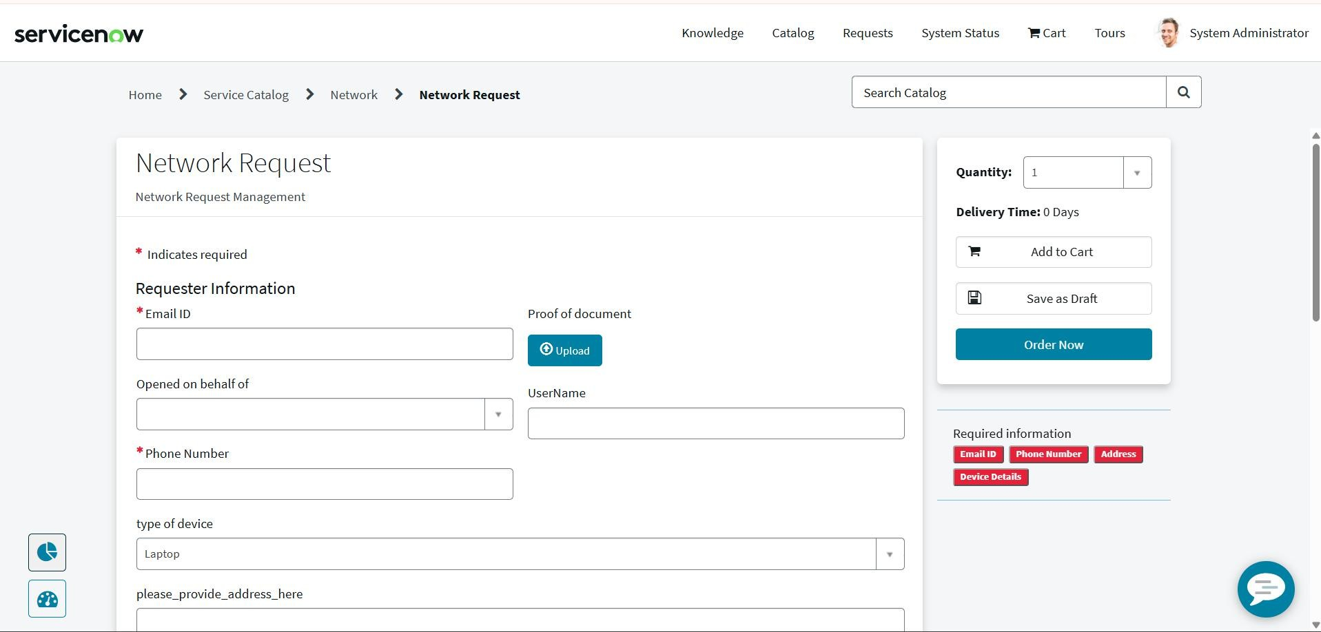
- Notifications: Inform users about approval and request progress.

- Requirement Analysis and Planning
The project requirements were identified to automate the complete network request process.
Functional Requirements:
- Users should submit network requests through the Service Portal.
- Required details must be captured using catalog variables.
- The system should create request and requested item records.
- Approval should be automated using Flow Designer.
- Approved requests should create Network Task records.
- Users should receive status updates and notifications.
Planning:
The implementation was divided into catalog configuration, table creation, flow automation, approval setup, notifications, testing, and deployment.

- Catalog Item and Variable Configuration
A Network Request Catalog Item was created to allow users to submit network-related requests.
The catalog item contains structured variables to collect the required request information. The Requested For field is automatically populated with the current user.
These variables ensure that complete and accurate details are captured before the request is submitted.
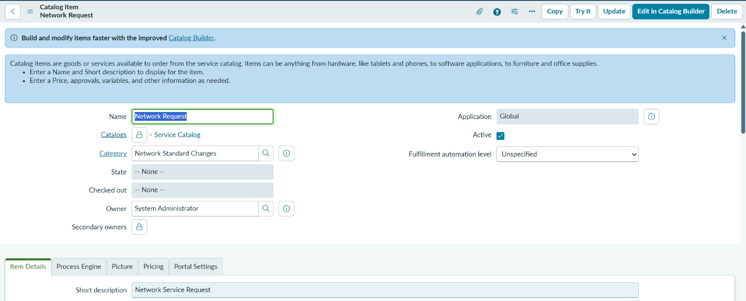
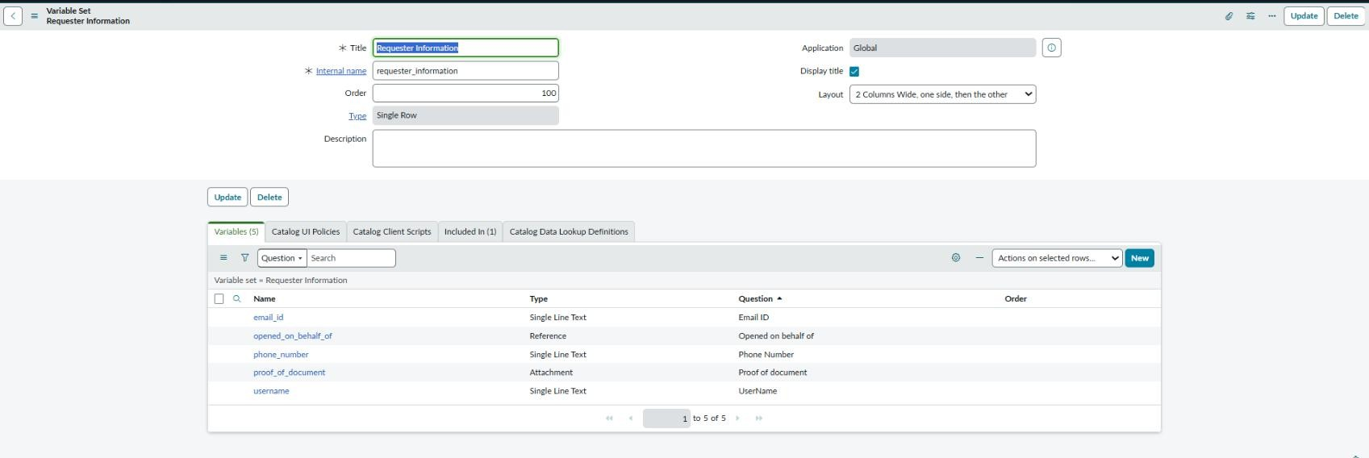
Fig 5.1Catalog Item Created
Fig 5.2 Variable Configuration

6. Service Portal Interface and Usability
The Service Portal provides a simple interface for users to submit network requests.
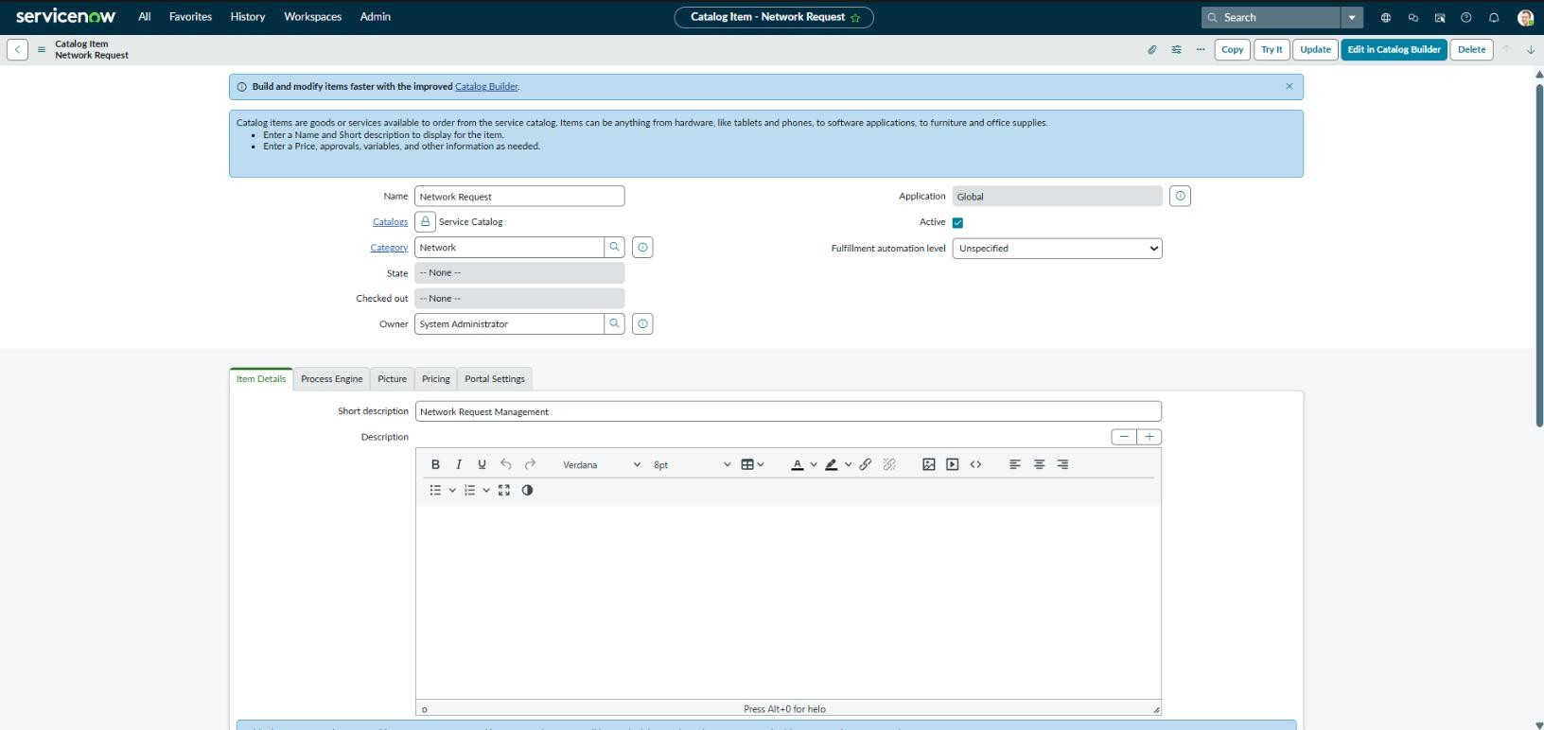
Users can open the Network Request Catalog Item, enter the required details, and submit the request. The structured form helps users provide complete information and makes the request process easier to follow.
Fig 6.1 Creation of Service Catalog
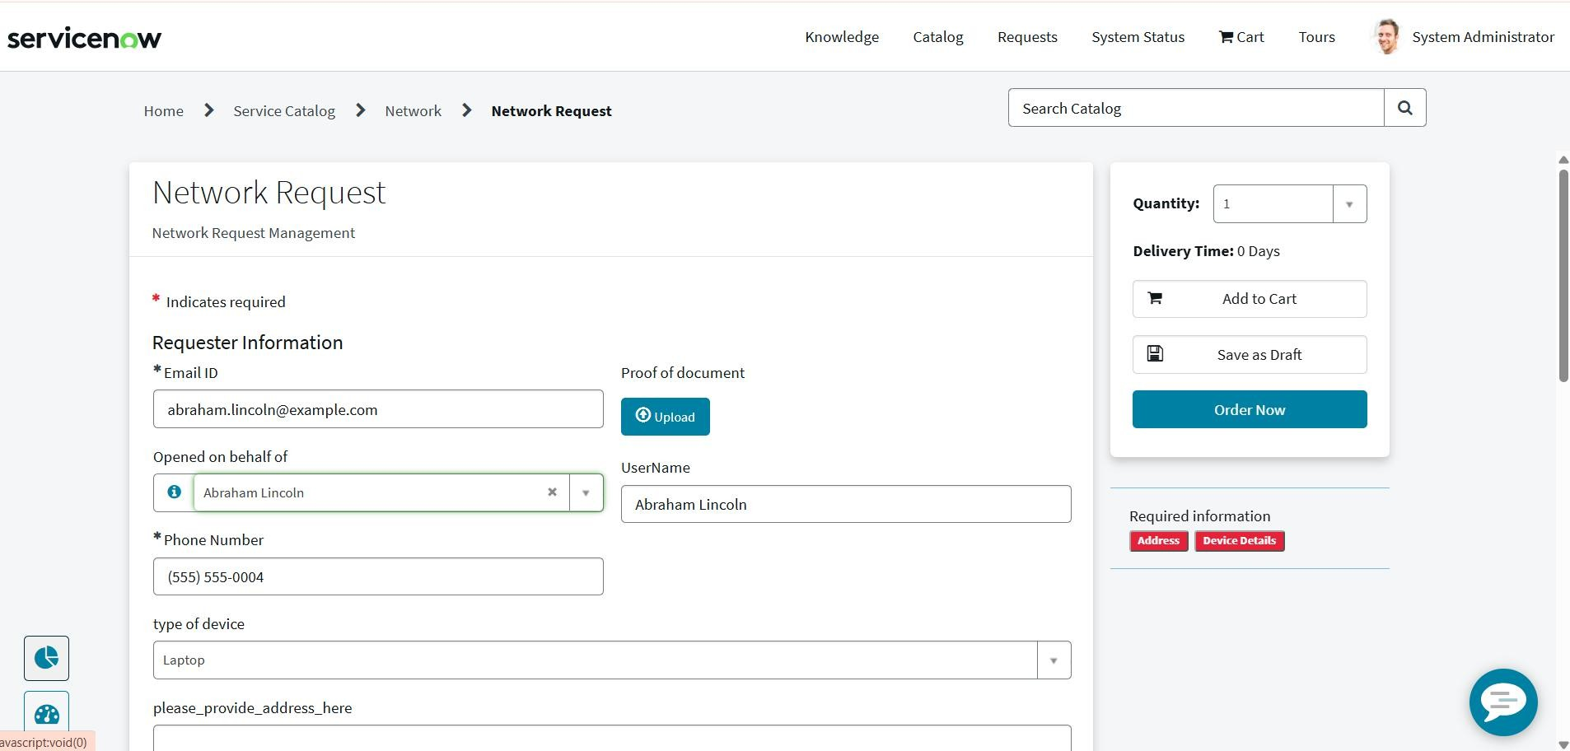

7. Flow Designer Automation
Flow Designer automates the network request process after a user submits the catalog item.
The flow creates the required Network Database record, routes the request for approval, and creates a Network Task when the request is approved. It also supports status updates and notifications.
Workflow:
Request Submission → Network Database Record → Approval → Network Task Creation → Status Update → Notification
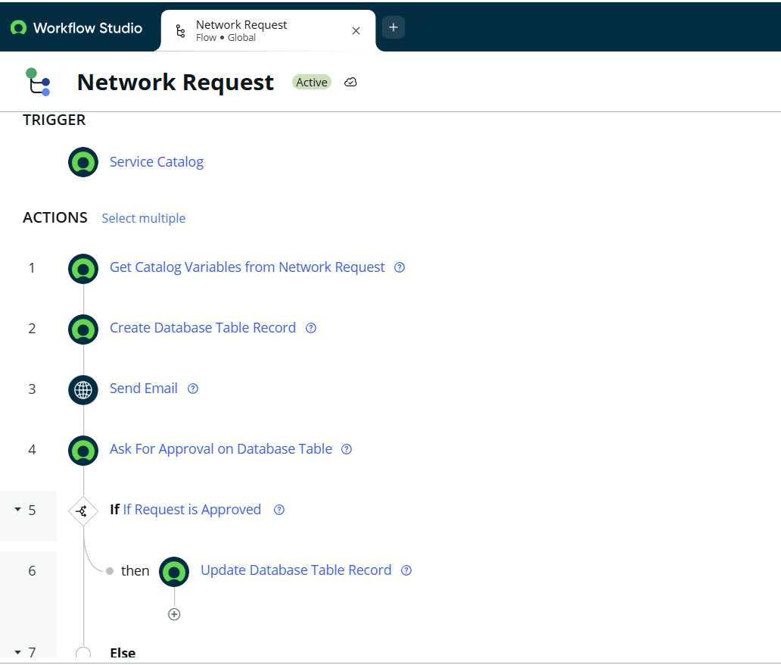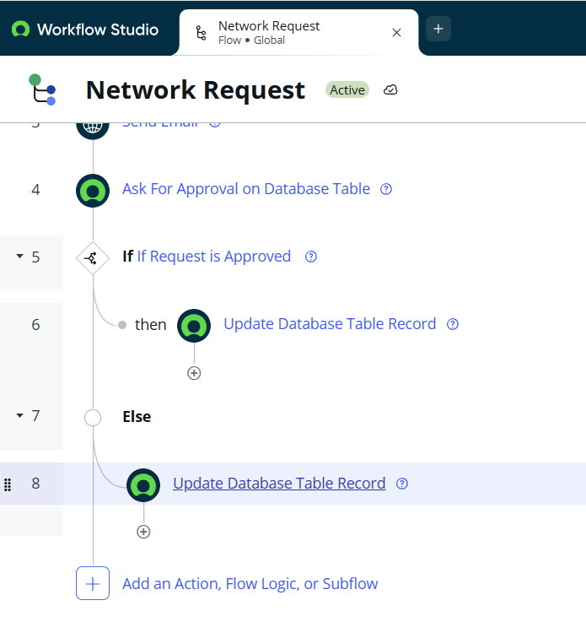
Fig 7.1 Creation of Flow
8. Approvals and Network Task
After the Network Database record is created, the request is sent for approval.
- The approver reviews the submitted request.
- If approved, a Network Task is created for fulfilment.
- The task helps the concerned team manage and complete the network request.
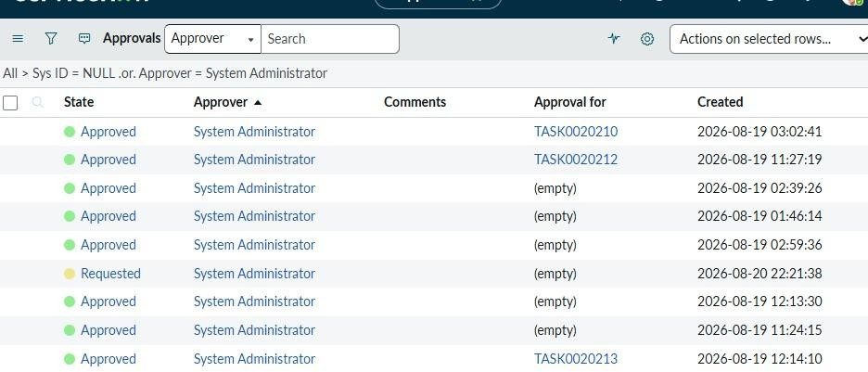
- The request status is updated throughout the process.

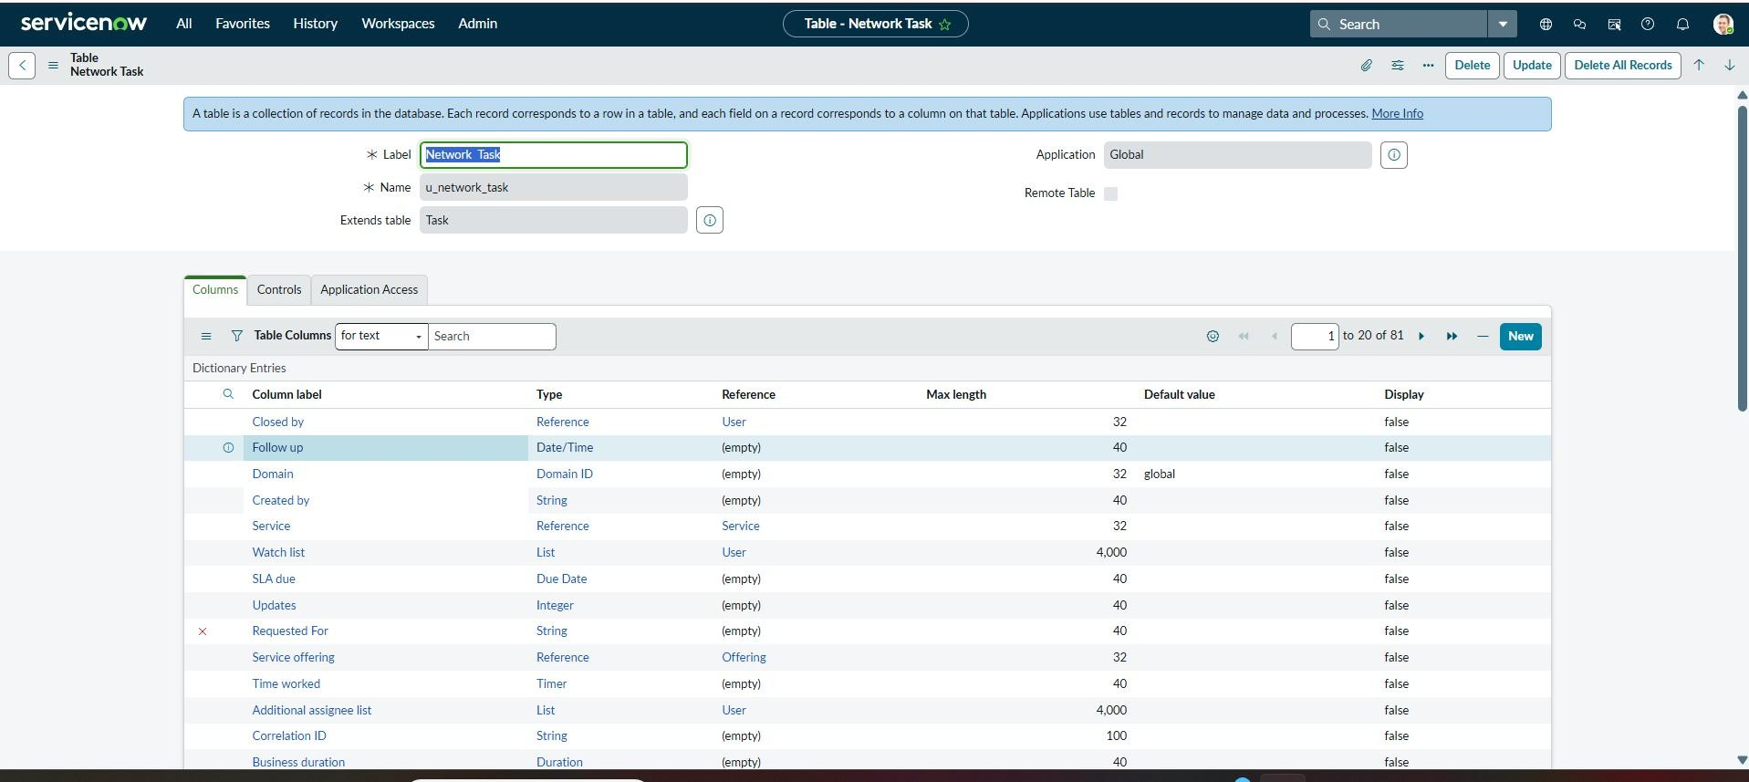
Fig 8.1 – Approval state evidence used for data-integrity validation
Fig 8.2 Network Task

9. Business Rules, UI Logic and ACLs
Business Rules and UI logic support the proper functioning of the network request process.
- Business Rules: Help manage request and task-related record processing.
- UI Logic: Supports the required form behaviour.
- Access Control Lists (ACLs): Control access to application records and ensure that only authorized users can view or modify them.
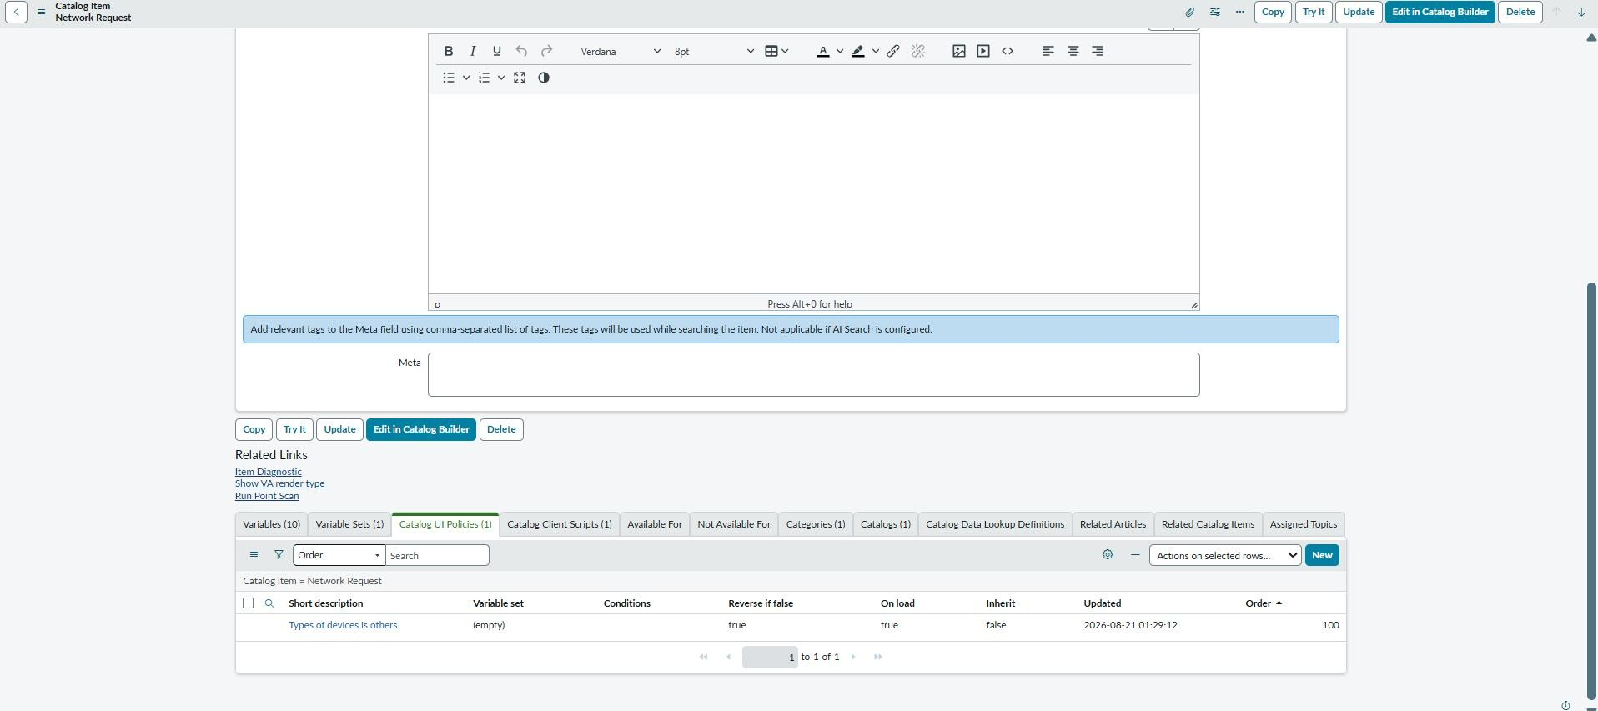
These configurations improve data security and maintain the correct request workflow.
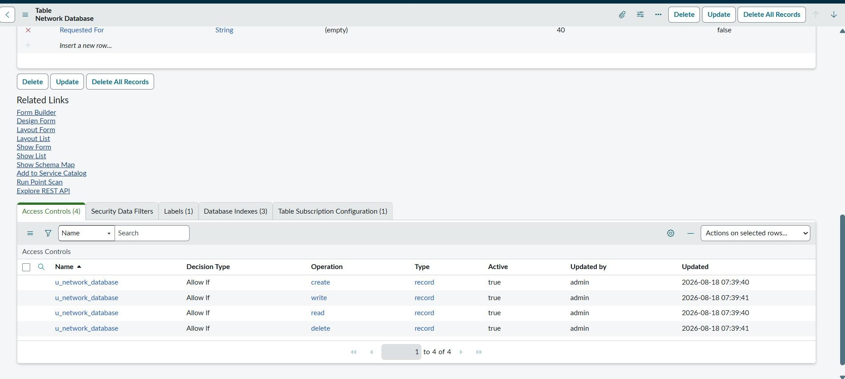
9.1 UI Policy
9.2 ACL created

10. Notifications and Status Tracking
The system updates the request status during the fulfilment process.
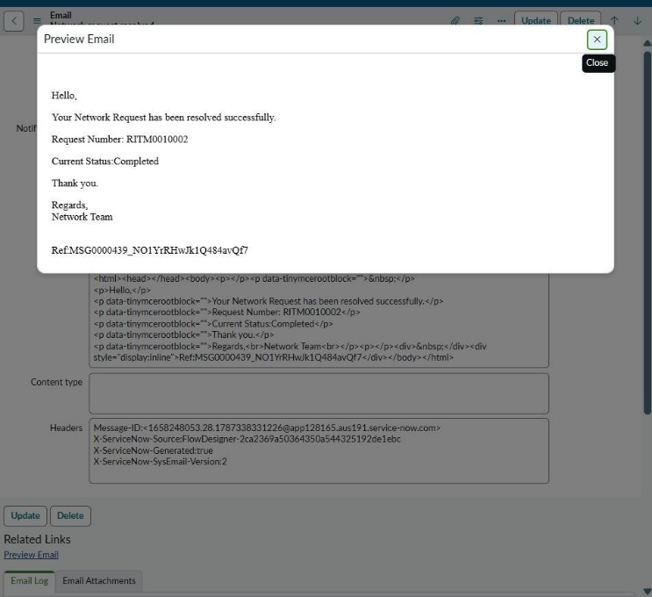
Notifications inform users about important request updates, such as approval and completion. This helps users track their network requests and understand the current progress.

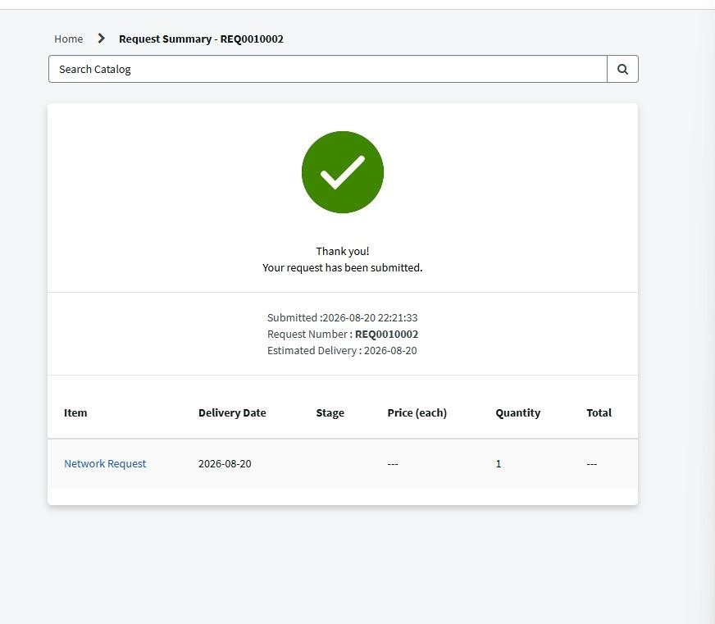
Fig 10.1 Email notification output

11. End-to-End Functional Flow
The complete network request process follows these steps:
- The user submits a Network Request through the Service Portal.
- ServiceNow creates the Request and Requested Item records.
- Flow Designer creates the Network Database record.
- The request is sent for approval.
- After approval, a Network Task is created.
- The concerned team works on the task.
- The request status is updated during fulfilment.
- Notifications inform the user about important updates and completion.
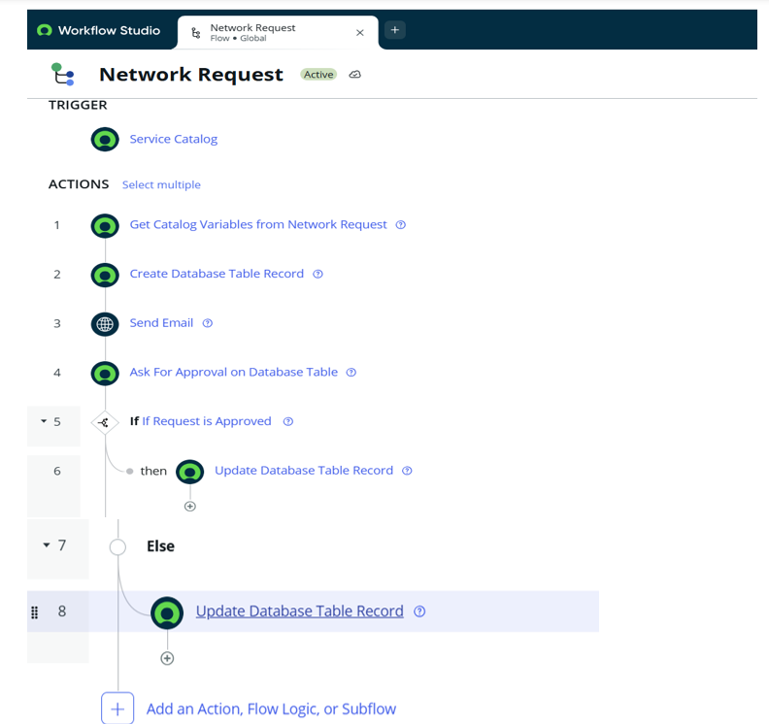

12. Testing and Validation
The project was tested to verify that the complete network request process works correctly.
The following functions were validated:
- Network Request Catalog Item submission.
- Mandatory field validation.
- Automatic population of the Requested For field.
- Creation of Request and Requested Item records.
- Creation of the Network Database record.
- Approval process.
- Network Task creation after approval.
- Request status updates.
- Email notifications.
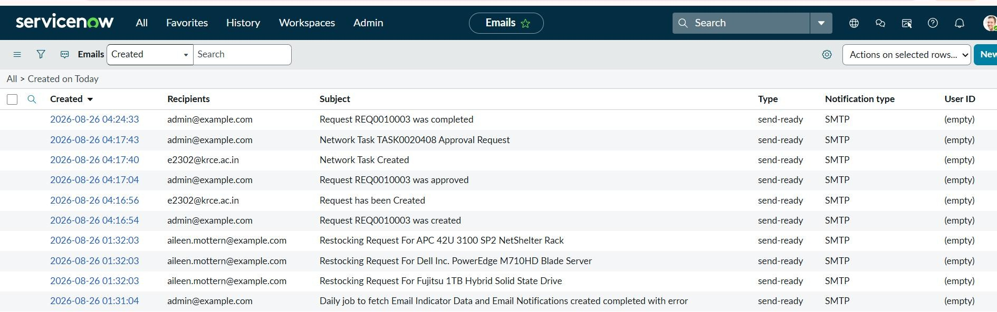
- Access control validation.

13. Deployment, Documentation and Presentation
The project was configured and tested on the ServiceNow platform. The implementation includes the catalog item, custom tables, Flow Designer automation, approvals, Network Tasks, notifications, ACLs, and Update Sets.
The project documentation explains the configuration steps, workflow, testing results, and overall functionality. Screenshots and execution evidence were used to demonstrate the working process.
14. Conclusion and Future Enhancements
The Automated Network Request Management system centralizes network request submission and automates approval, task creation, status tracking, and notifications.
The project reduces manual effort and improves visibility throughout the request lifecycle.
Future Enhancements:
- Add more request types and approval levels.
- Introduce additional fulfilment automation.
- Create dashboards and detailed reports.
- Expand role-based access and validation.
- Improve portal tracking and confirmation pages.

